Date | 22 June 2026
Project Name | Network Anomaly Detection
Maximum Marks | 4 Marks

Data Flow Diagram:

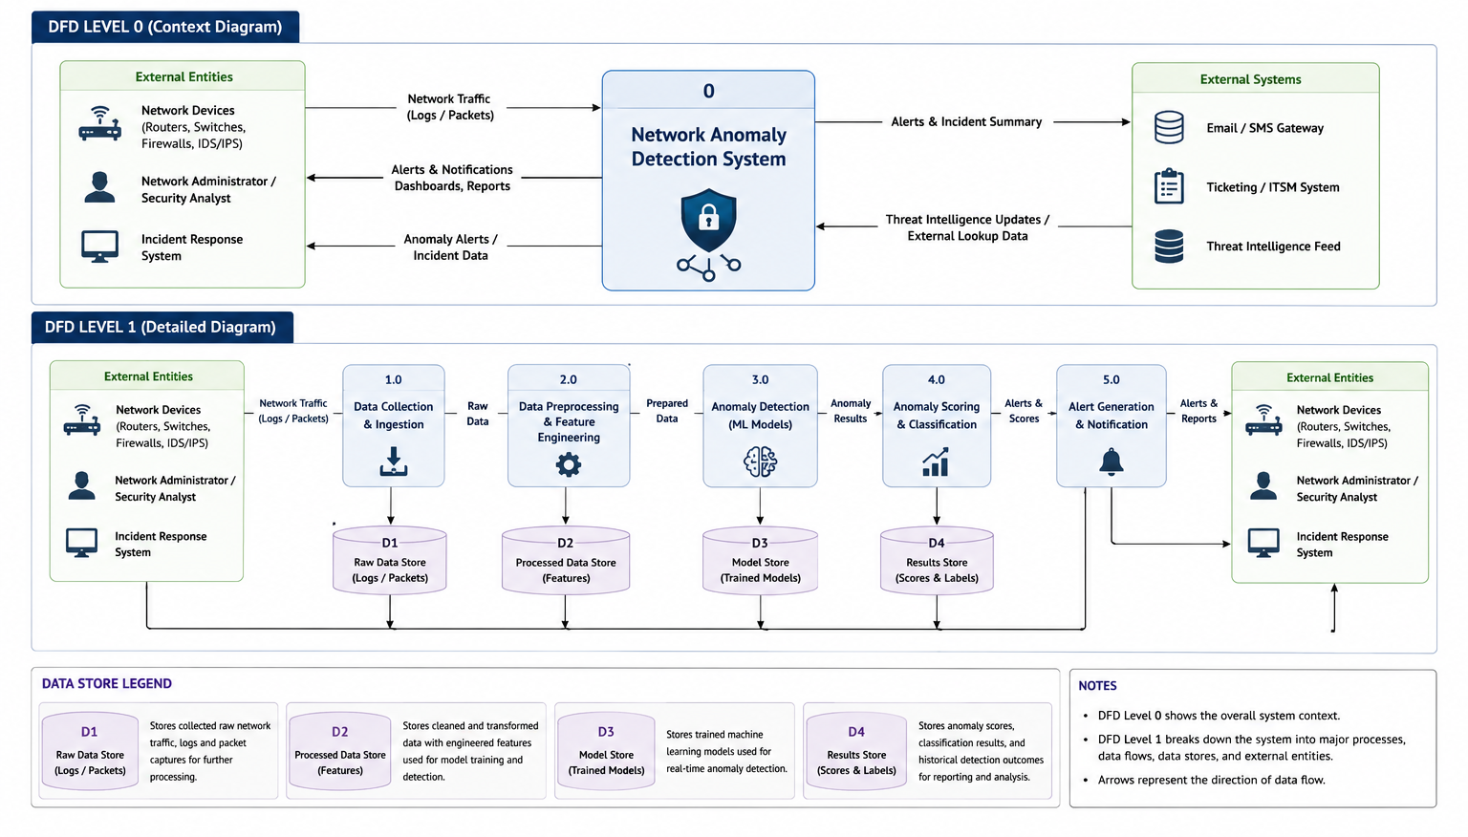

User Stories:
User Type | Functional Requirement (Epic) | User Story Number | User Story / Task | Acceptance criteria | Priority | Release / Sprint
Network Administrator | Data Monitoring | USN-1 | As a Network Administrator, I can upload network logs and packet capture files for analysis. | Logs are uploaded successfully and visible in the system. | High | Sprint-1
Network Administrator | Data Monitoring | USN-2 | As a Network Administrator, I can view real-time network traffic statistics. | Dashboard displays live network metrics. | High | Sprint-1
Network Administrator | Anomaly Detection | USN-3 | As a Network Administrator, I can run anomaly detection on network traffic. | System identifies anomalous traffic patterns. | High | Sprint-1
Network Administrator | Alert Management | USN-4 | As a Network Administrator, I receive alerts when anomalies are detected. | Alert notification is generated automatically. | High | Sprint-2
Network Administrator | Dashboard | USN-5 | As a Network Administrator, I can view detected anomalies on a dashboard. | Dashboard shows anomaly details and severity. | High | Sprint-2
Security Analyst | Investigation | USN-6 | As a Security Analyst, I can analyze anomaly details and supporting evidence. | Detailed anomaly report is available. | High | Sprint-2
Security Analyst | Severity Classification | USN-7 | As a Security Analyst, I can classify anomalies based on risk level. | System displays Low, Medium, High, Critical severity. | Medium | Sprint-2
Security Analyst | Reporting | USN-8 | As a Security Analyst, I can generate anomaly reports. | Reports can be exported in PDF/CSV format. | Medium | Sprint-3
Administrator | User Management | USN-9 | As an Administrator, I can manage user accounts and permissions. | User roles and permissions can be updated. | Medium | Sprint-3
Administrator | Model Management | USN-10 | As an Administrator, I can retrain and update anomaly detection models. | New model versions can be deployed successfully. | Medium | Sprint-4
Administrator | System Monitoring | USN-11 | As an Administrator, I can monitor system health and performance. | System status metrics are displayed. | Medium | Sprint-4
Incident Response Team | Incident Handling | USN-12 | As an Incident Response Team member, I can receive anomaly alerts and investigate incidents. | Incident tickets and alerts are created automatically. | High | Sprint-4

